**Introduction:**

***Overview:***

I am Kavitha P.I am the team leader of the naan mudhalvan project.My project is “Tracing the growth of global community. A population Forecasting”.Here are my team members.They are Lavanya.K,Kiruthika.V,priyadharshini.C.We explained about population over by countries,cities,year and also sex.We give complete details about the project in Dashboard(like dashboard 1,2,3).This project explained about how population increases and decreases,what are the problem they facing.In our project we explained about the advantages and disadvantages of population and importances of sex growth over many countries like China,USA,India,ect..., In our project ,we pinned some details about Global Community of population. In what are the way they increase and decrease and affect the growth.

*PURPOSE:*

The purpose is to provide information on their spatial distribution, age and sex structure and other key social and economic characteristics and this project is used to understand easily about the population growth of World.

**PROBLEM DEFINITION AND DESIGN THINKING:**

***EMPATHY MAP:***

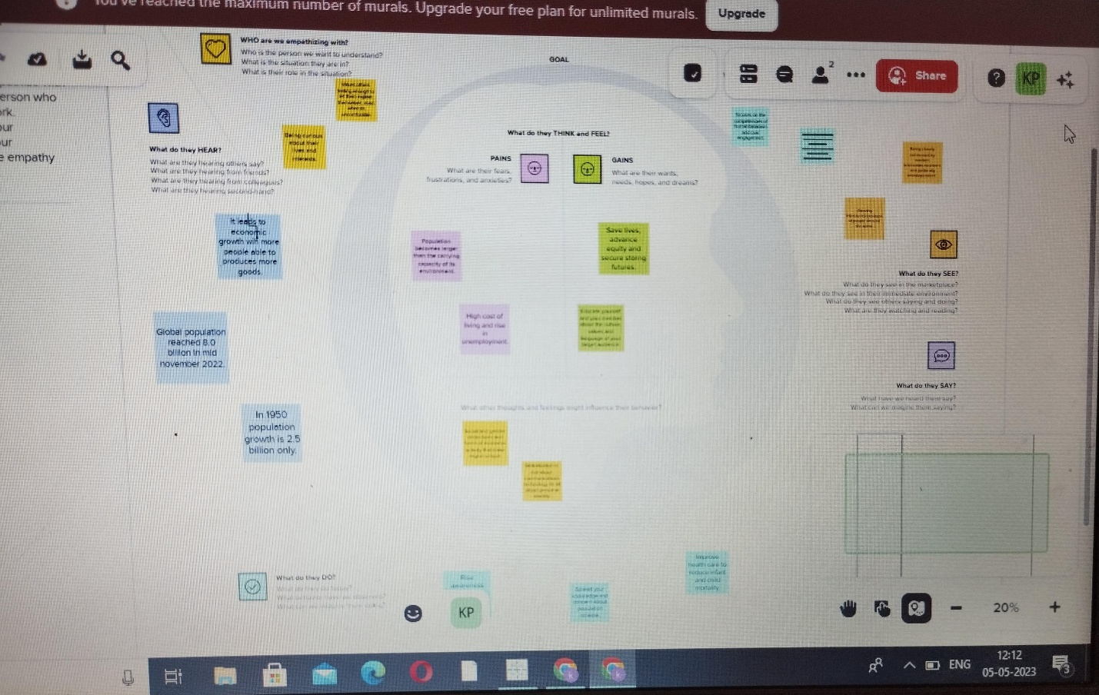

**IDEATION & BRAINSTORMING MAP:**

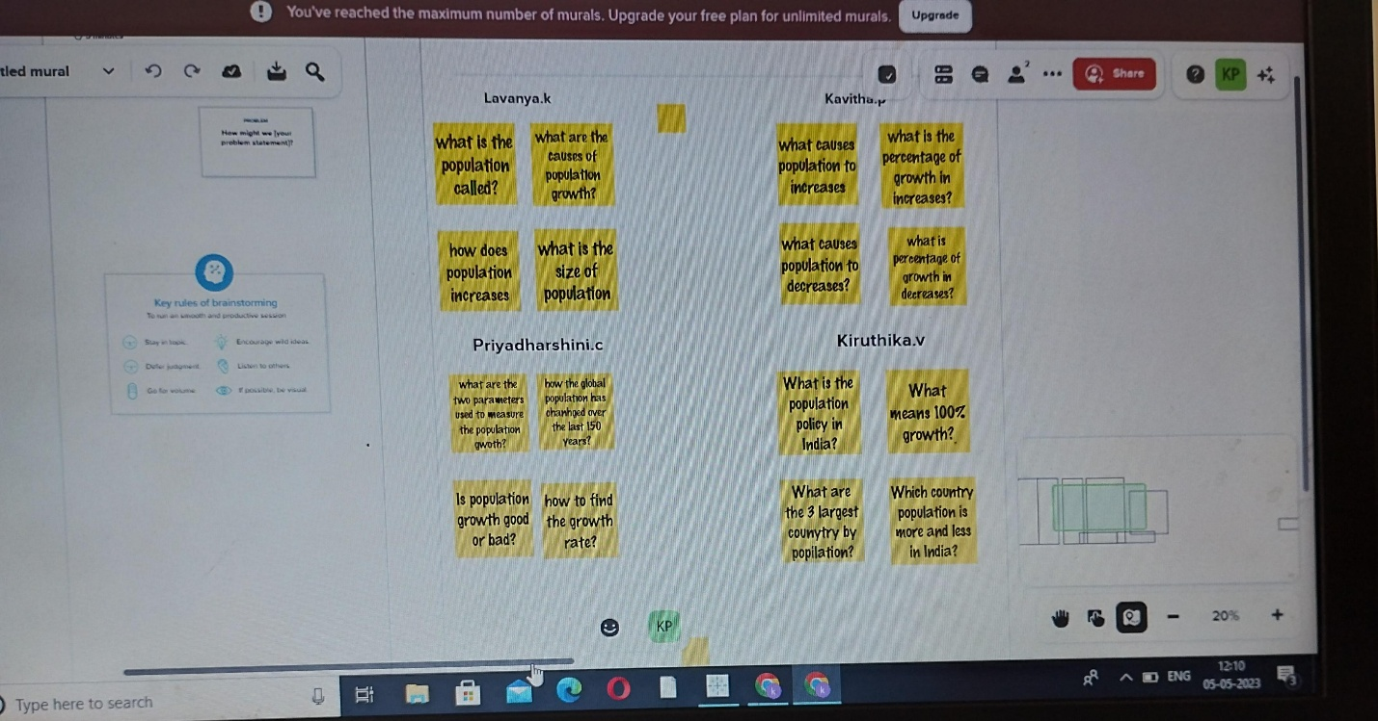

**RESULT:**

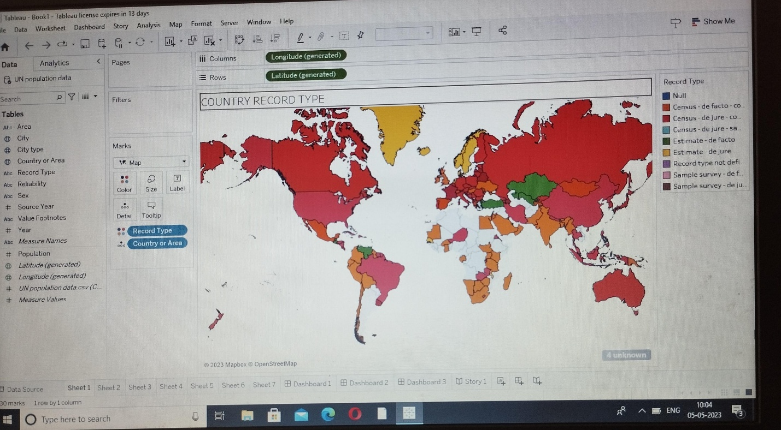

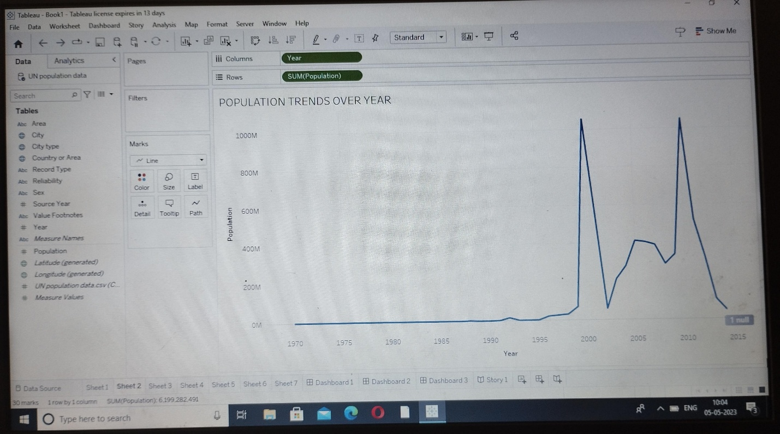

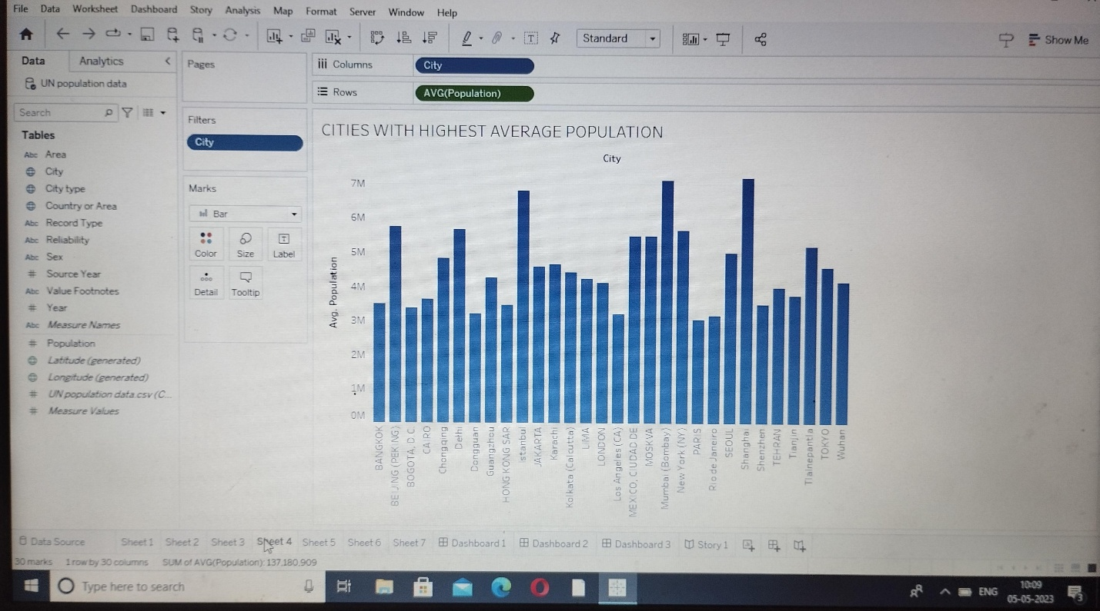

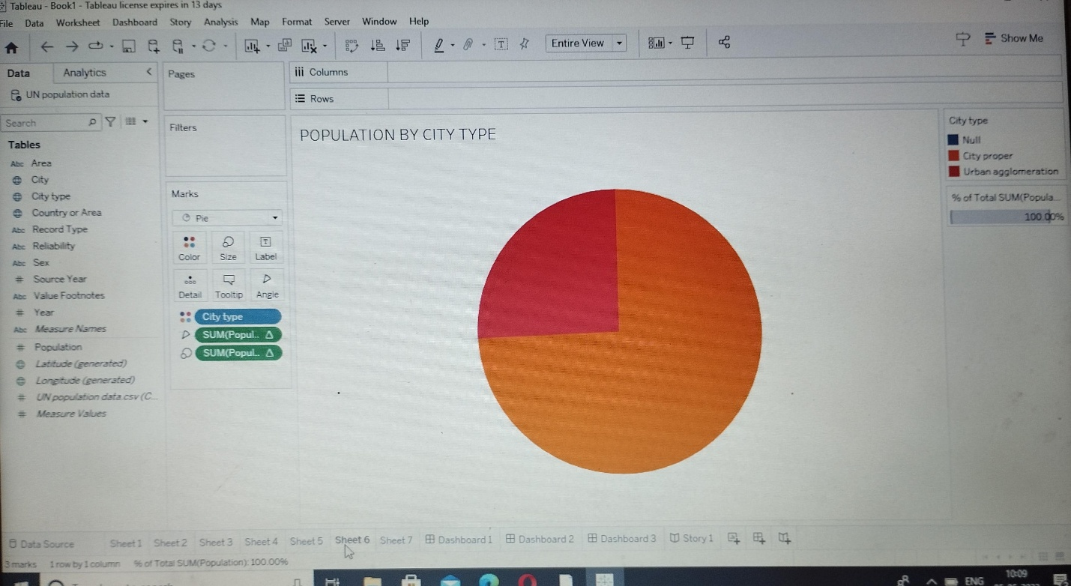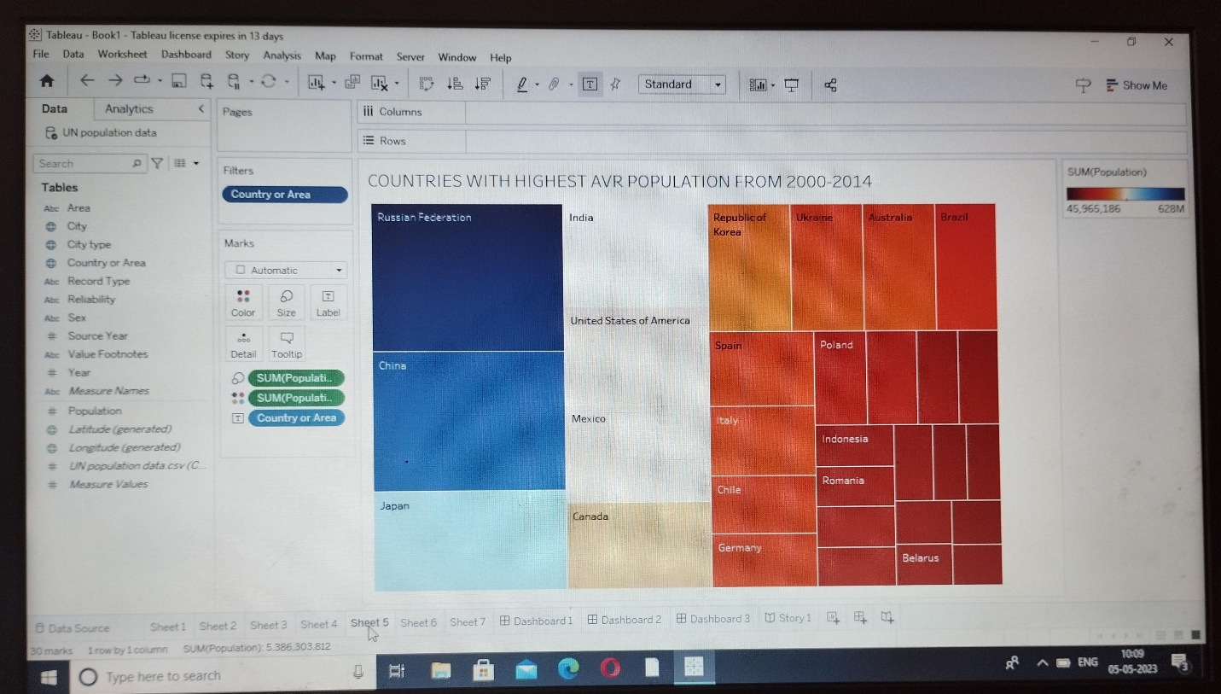

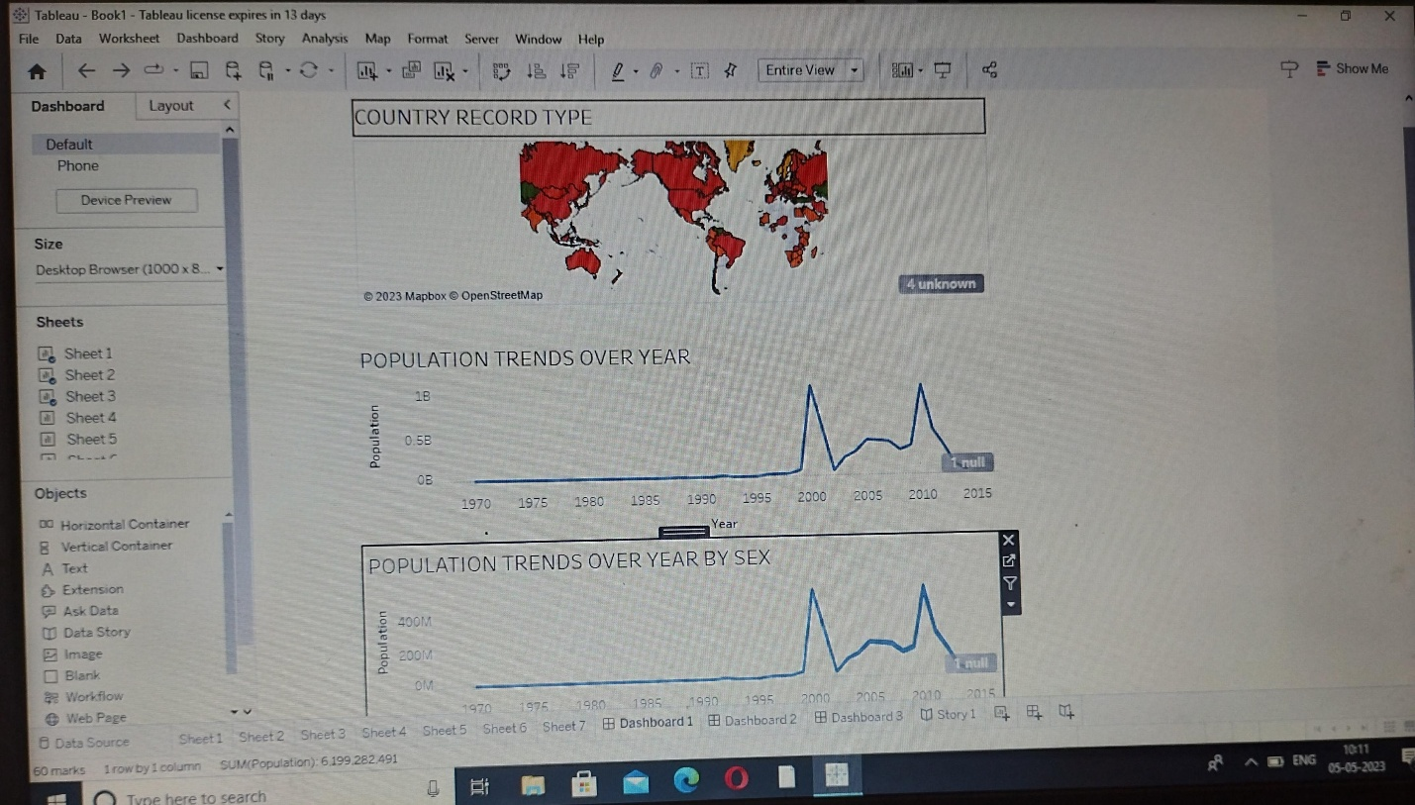

**ADVANTAGES AND DISADVANTAGES:**

***ADVANTAGES:***

* **More people leads to greater human capital**
* ***The efficiency of higher population density***
* ***Economic of scale***

**DISADVANTAGES:**

* **Unemployment**
* **Increase in crime rate**
* **Pressure on social amenities**

**APPLICATION:**

**Forest and other habitats are disturbed or destroyed to construct urban areas including the construction of homes, business and roads to accommodate growing population.**

**Visit the Burning of fossil fuels, agricultural activities and urbanisation pages to learn more about how processes and phenomenon related to the size and distribution of human population affect global climate and ecosystem.**

**CONCLUSION:**

**The Earth’s current population is almost 7.6 Billion people and it expanding.It is expected to surpass 8 billion people by 2025,9 billion by 2040,and 11 billion by 2100.**

**FUTURE SCOPE:**

**We achieved a sustainable human population,to protect nature and improve lives.**

[**http://www.populationmatters.org**](http://www.populationmatters.org)

**Visit the above website to know about the scope of world’s population.**

**APPENDIX:**

*SOURCE CODE:*

**The main source and components of population change a birth,death and migration.**

***Website:***

[***http://ourworldindata.org***](http://ourworldindata.org)

**Visit the above website to know about the total development of world population..**

**Thank you...**